Installation of Anaconda

1. Go to <https://anaconda.org/anaconda/continuum-docs> and download the latest version of anaconda

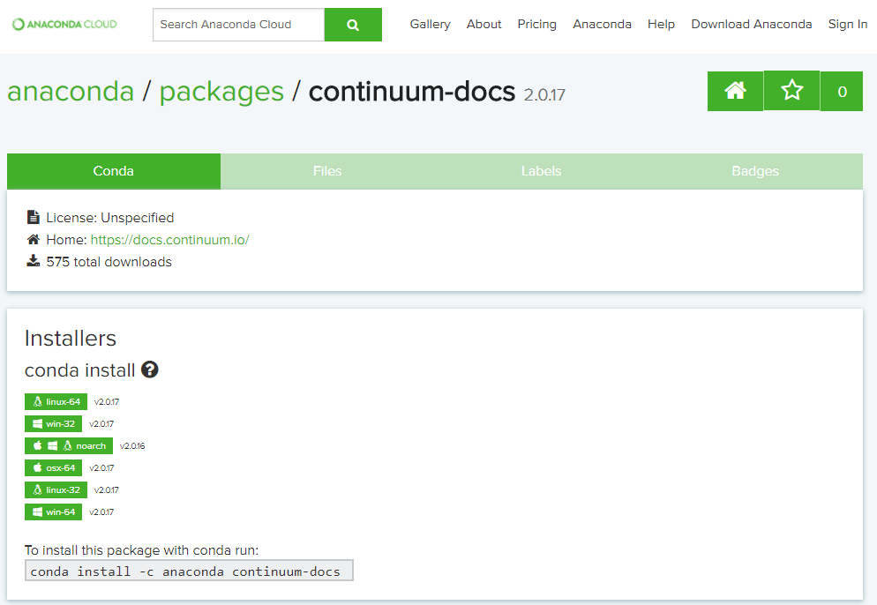

1. Run the setup and install anaconda, **please make sure you add anaconda directory to the PATH variable**

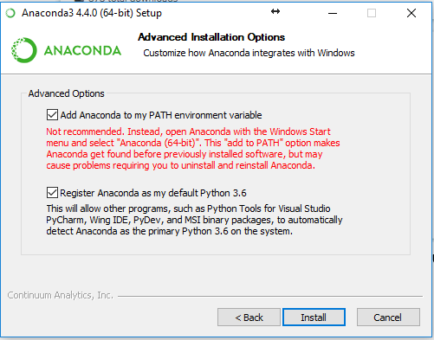

1. Open the cmd and type the following command:

conda install -c menpo opencv

1. Type this following command to launch jupyter notebooks

jupyter notebook